Name: Furthose samreen B

Reg NO: 192511164
Experiment 3 : E-Commerce Mobile App Prototype Using Figma Aim
To create an interactive prototype of an E-Commerce mobile application using Figma to present UI design options, collect stakeholder feedback, and obtain approval for the final design.

Procedure

- Open the Figma website and log in to your account.

- Create a new design file named E-Commerce Mobile App Prototype.

- Create a mobile frame using the Frame tool.

- Design the Home Page with a search bar, product categories, product images, and prices.
- Create a Product Details screen with product information, price, description, and an Add to Cart button.
- Design a Shopping Cart screen displaying selected products, quantities, total price, and a checkout button.
- Create two alternative home page designs to address different stakeholder preferences.

- Use the Prototype tab to connect the screens and create interactive navigation.

- Present the prototype to stakeholders and collect their feedback on layout, colors, navigation, and usability.
- Modify the design based on feedback and obtain approval for the final design.

Output

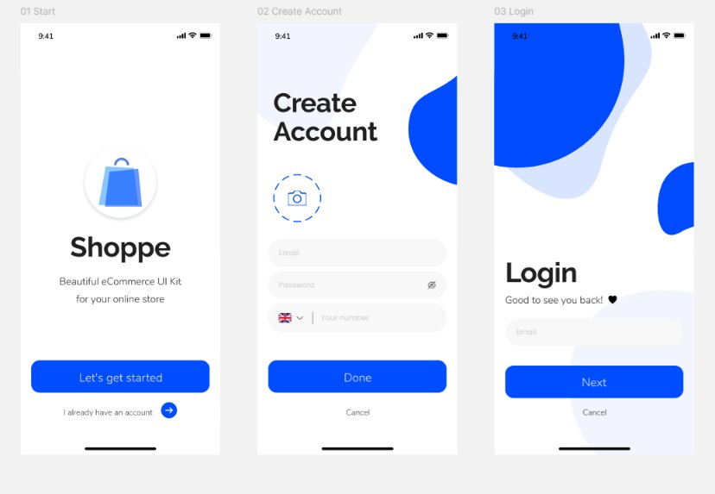
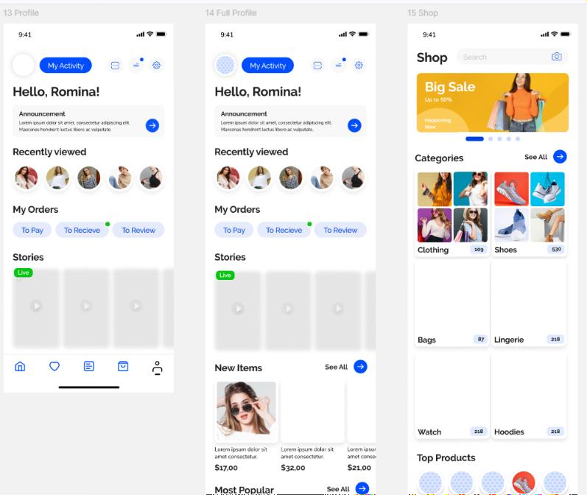

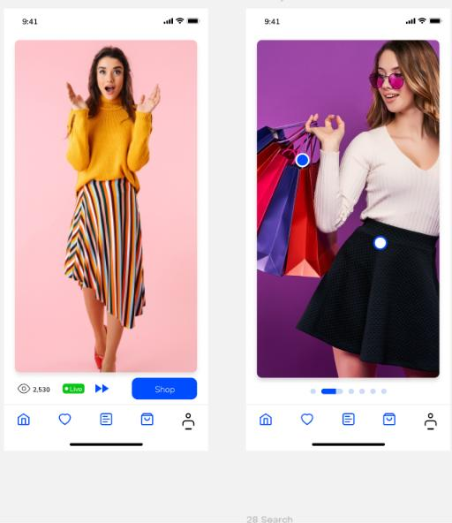
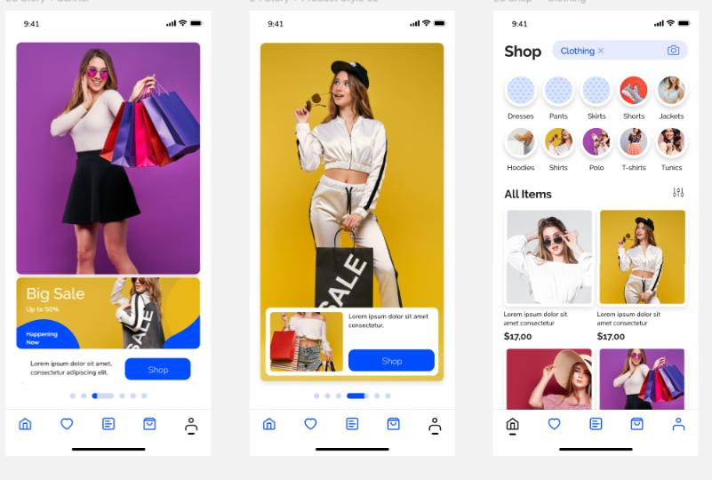

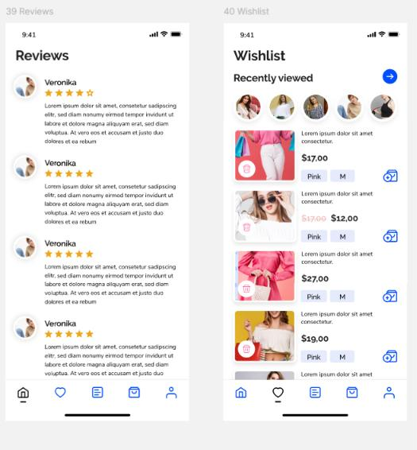
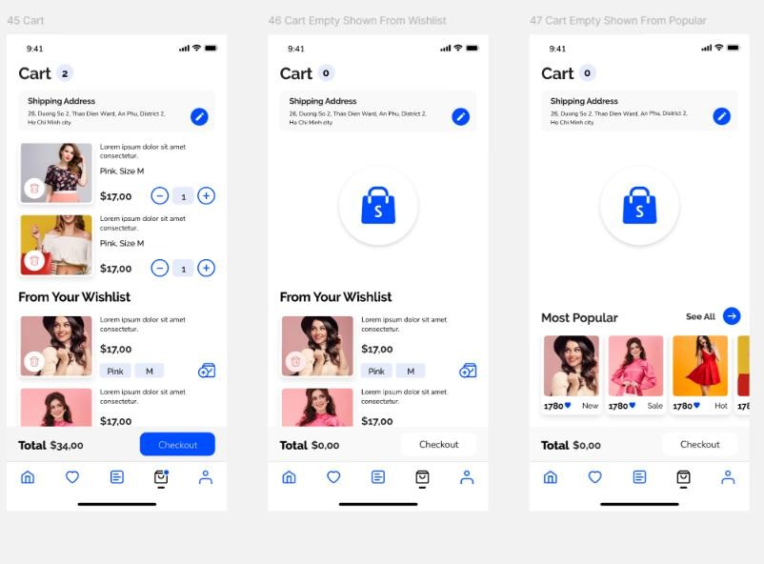

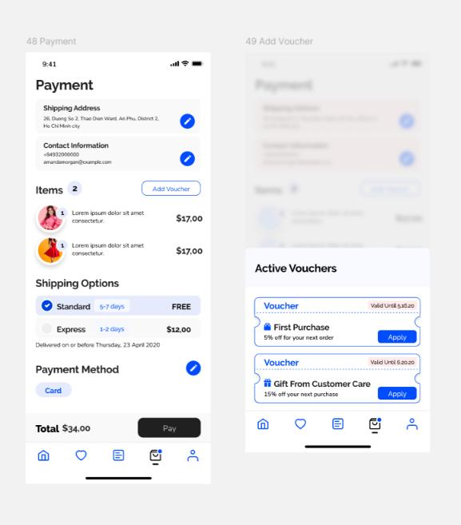
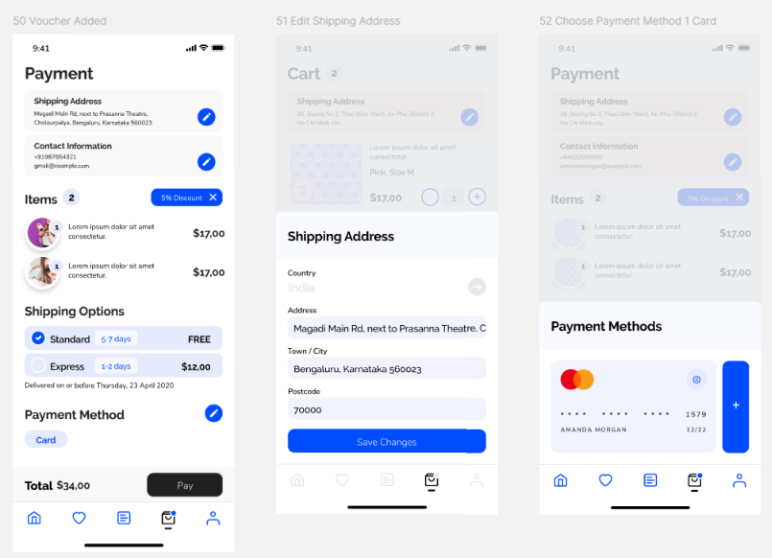

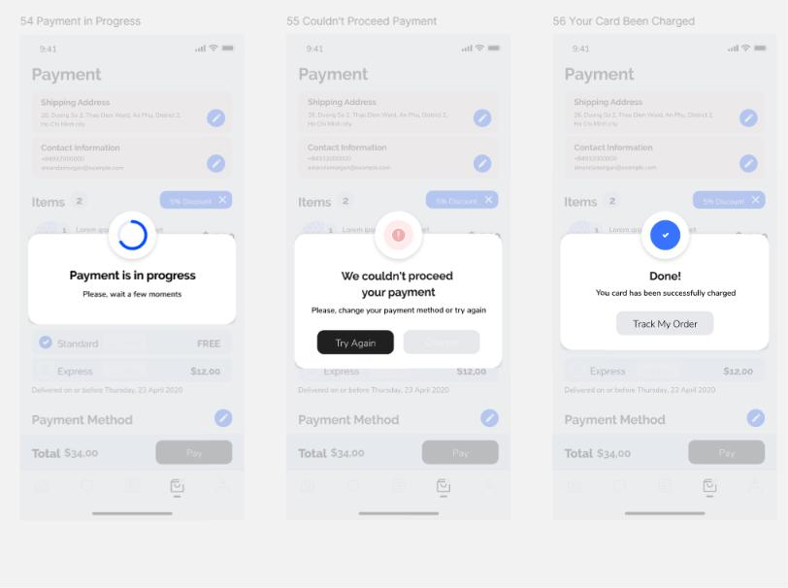

Result

An interactive E-Commerce mobile application prototype was created using Figma. Alternative UI designs were presented to stakeholders, their feedback was collected, and the prototype was refined to support approval of the final interface design.

GITHUB LINK:
https://github.com/192511164simats-source/Software-engineering-

